18/07/23

* Modify Visual Studio Installer

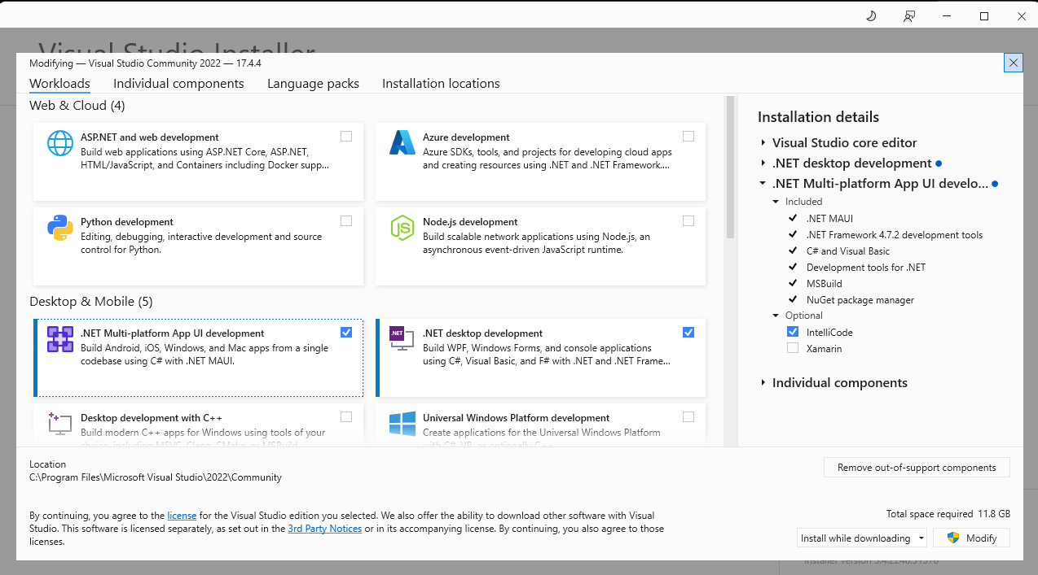

Open APIs

[Big List of Free and Open Public APIs (No Auth Needed) [2023] (mixedanalytics.com)](https://mixedanalytics.com/blog/list-actually-free-open-no-auth-needed-apis/)

As of my last update in September 2021, there were several open APIs related to food and nutrition that developers could use to develop mobile applications. Please note that the availability and popularity of APIs may change over time, so it's a good idea to verify their current status and terms of use before integrating them into your application. Here are some of the notable food-related APIs:

1. Edamam API: Provides access to a vast database of food and nutrition data, including recipes, ingredients, and nutritional information.

2. Spoonacular API: Offers recipe search, meal planning, and nutrition analysis capabilities.

3. Nutritionix API: Provides nutrition data for various foods and ingredients, including restaurants and branded foods.

4. USDA FoodData Central API: Maintained by the United States Department of Agriculture (USDA), this API offers extensive nutrient information for a wide range of foods.

5. Food2Fork API: Allows access to a large collection of recipes from various sources.

6. Open Food Facts API: Offers information on food products, including ingredients, nutritional data, and allergens.

7. Yelp Fusion API: While not exclusively focused on food, it allows you to access restaurant data, reviews, and other related information.

8. TheCocktailDB API: If your app involves beverages, this API offers a vast collection of cocktail recipes.

9. BreweryDB API: If you're developing a beer-related app, this API provides data on breweries and beers.

10. Wine.com API: For wine-centric applications, this API grants access to an extensive wine catalog.

Remember that each API may have specific terms of use and limitations, such as rate limits and usage restrictions. Always review the documentation and abide by the terms to ensure compliance and avoid any potential issues. Additionally, if you are looking for APIs beyond these examples, you can search for more recent options and reviews from reliable developer resources and API marketplaces.

* [Build your first .NET MAUI app - .NET MAUI | Microsoft Learn](https://learn.microsoft.com/en-us/dotnet/maui/get-started/first-app?tabs=vswin&pivots=devices-android)
* <https://www.tutorialspoint.com/csharp/index.htm>

Edamam is a platform that provides nutrition analysis and recipe recommendations. When brainstorming ideas for a mobile app that integrates with Edamam, there are several possibilities to consider:

1. Personalized Meal Planning: Develop a mobile app that utilizes Edamam's nutrition analysis capabilities to create personalized meal plans based on users' dietary goals, preferences, and restrictions. The app could provide recipe recommendations, grocery lists, and track users' nutrition intake.

2. Recipe Finder: Create a mobile app that allows users to search for recipes based on specific dietary needs or ingredients. The app can utilize Edamam's recipe database to provide a wide range of options and offer filtering options such as vegetarian, gluten-free, or low-calorie recipes.

3. Meal Tracking and Journaling: Design a mobile app that enables users to track their meals and log their nutritional intake. The app can integrate with Edamam's nutrition analysis to provide users with insights into their daily calorie intake, macronutrient distribution, and other nutritional information.

4. Allergen Detection: Develop a mobile app that utilizes Edamam's API to scan food products' ingredients lists and detect potential allergens. This app could be helpful for individuals with food allergies or sensitivities and provide them with an easy way to identify safe food options.

5. Virtual Nutritionist: Create a mobile app that offers personalized nutrition advice and recommendations based on users' specific health goals. The app can utilize Edamam's nutrition analysis capabilities to provide tailored meal plans, recipe suggestions, and dietary guidance.

Remember to consider the target audience, usability, and potential market demand when choosing the best idea for an app that integrates with Edamam. Conducting user research and gathering feedback throughout the brainstorming process will help refine and prioritize the ideas accordingly.

